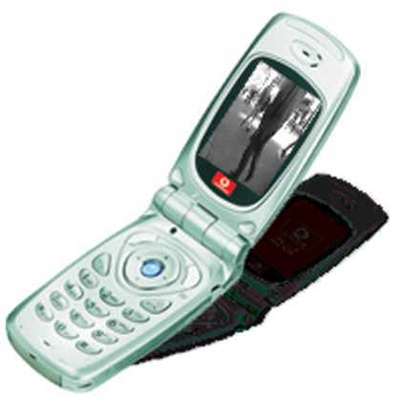
doc_u

Information for Parents of Children under 16

Dear Parent,

Your child expressed an interest in taking part in the doc_u project. This letter is to introduce the project to you and allow you to make an informed decision as to whether to let you child be involved in the project. Please read this information carefully, sign and return the form to the Babylon Gallery or email a copy to Jess Loseby (details below)

doc_u will be a new digital artwork I am creating for the Babylon Gallery in Ely. During this time we are asking people to become involved in the project by making their own visual documentaries (doc_u’s) using mobile phone cameras. If you have received this letter it may be that you child has been invited to a doc_u workshop, would like to borrow the doc_u ‘library’ phone available at the Babylon Gallery or has found this project on the Internet and would like to take part.

In using images involving or taken by children, the Babylon Gallery and my own primary concern is the child’s privacy and safety. I am also a mother of three small children and feel passionately that children should be able to explore digital art safety and responsibly. This is particularly crucial to the artwork doc_u as it will be displayed both in the public Babylon Gallery and on the Babylon Gallery website and its own Internet website. The following strict rules have been and will be adhered to in order to protect your child’s privacy.

- No work will be used in the artwork doc_u until a child’s parent or guardian has given consent. Images taken by children whose parents do not give their consent will be permanently deleted from phones or the website
- Children are only referred to in the doc_u artwork by first name initials, age, gender and general location (e.g. Soham, Ely). No First or Last names are given in the artwork or website.
- All photographs in the work are technically ‘locked’ as a group into an animation format called ‘Flash’. This makes it incredibly complicated to access the photos individually when shown on the Internet. This means that individual photos cannot be independently downloaded, copied, entered into search engines ‘image’ tools or used within other webpages. Images uploaded using the online form (rather than sent via email or through the Gallery) are less secure. However, all steps possible have been taken to provide security and anonymity. It is
- Parents of children under 16 have the authority at any time to ask for their child’s work to be removed from the project.
- Jess Loseby will remove any submitted images from the project if it is suspected that a child under 16 has entered them.

Please see http://www.doc-u.co.uk to see the artwork and how children and young adults have already taken part in the project. You will need an Internet connection, I.E 6+ and the Flash plug-in to see this work on your home computer.

In addition, participants in the artwork may be entered into a competition to win the mobile phones (5 x Samsung VGA 1000) used in creating the project. Winning images will be selected when the doc_u artwork is exhibited in 2005. To maintain children’s privacy, only groups of children who all have parental or guardian consent may be put forward to win these phones. A contact email or telephone number must also be supplied to be entered into this competition.

If parents, teachers, siblings or friends would like to make their own doc_u (and maybe, also win a phone!) the Babylon Gallery has a mobile phone camera that can be taken out on loan. Participants under 16 must have parental consent. Please contact the Babylon Gallery for more details.

If you are happy to give your permission please return this form, signed and dated to your child’s directly to the Babylon Gallery (details below) or copy and send by email.

If you still have any concerns or questions, please contact Claire Townsend at Babylon Gallery or Jess Loseby (jess@rssgallery.com)

Yours sincerely,

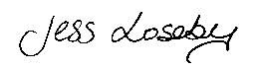

Jess Loseby and the Babylon Gallery.

Doc_u Permission Form

I do / do not give my permission for the photographs of or by my child to be used in the digital artwork ‘doc_u’ by Jess Loseby for the Babylon Gallery. I understand that this work will be published on the Babylon Gallery website, on the Internet at www.doc-u.co.uk and exhibited publicly in the Babylon Gallery in Ely.

My child’s first name initial is ……

My child’s age is ……
My child is a Boy/Girl

(This is to identify your child’s work as no full names have been recorded)

I do / do not give my consent for my child to be entered into the competition to win one of the doc_u mobile phones.

(Signed)………………………………………..(Parent / Guardian)

(Date) …………………………………………

Please sign and return to:

Claire Townsend
Babylon Gallery
Waterside
Ely
Cambridgeshire CB7 4AU
t. 01353 669022
f. 01353 669052
e. info@adec.org.uk

or copy and email to jess@rssgallery.com
PDF or word (doc) versions of this form are available at: http://www.doc-u.co.uk

